Created - Train And Test Folders

**Team ID**PNT2022TMID09663

**Project Name:** Real time Communication system powered by AI for Specially for Abled

**Team Lead** : Saatvika

**Team Members** : Rajkumar P, PRAVEEN KUMAR M,Sabarivasan M

Stage 1: D:\IBM PROJECT – AI

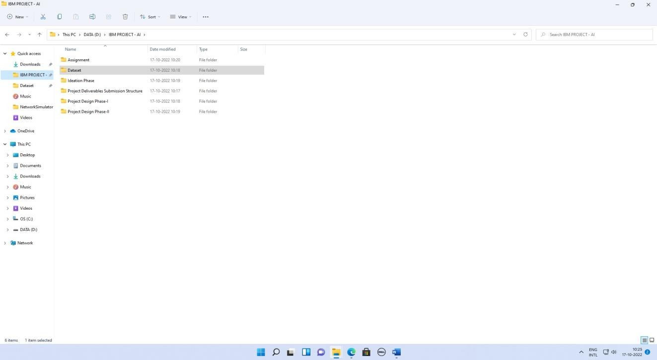

Stage 2: D:\IBM PROJECT – AI

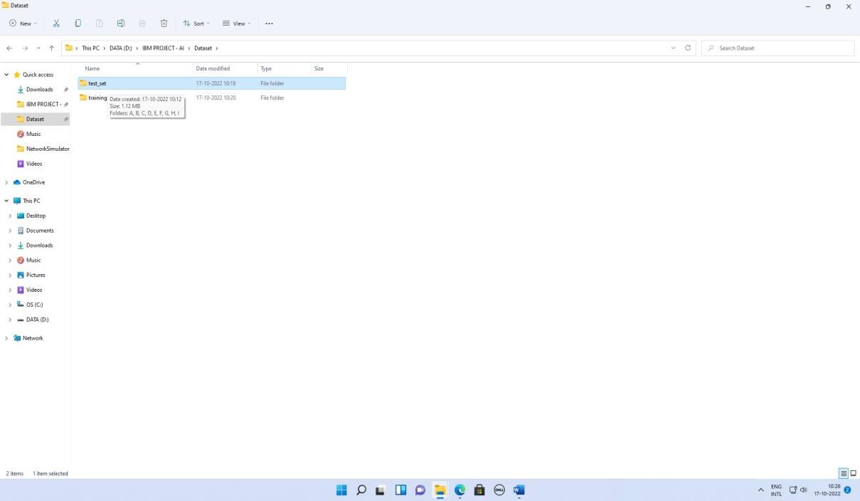

Stage 3: D:\IBM PROJECT – AI

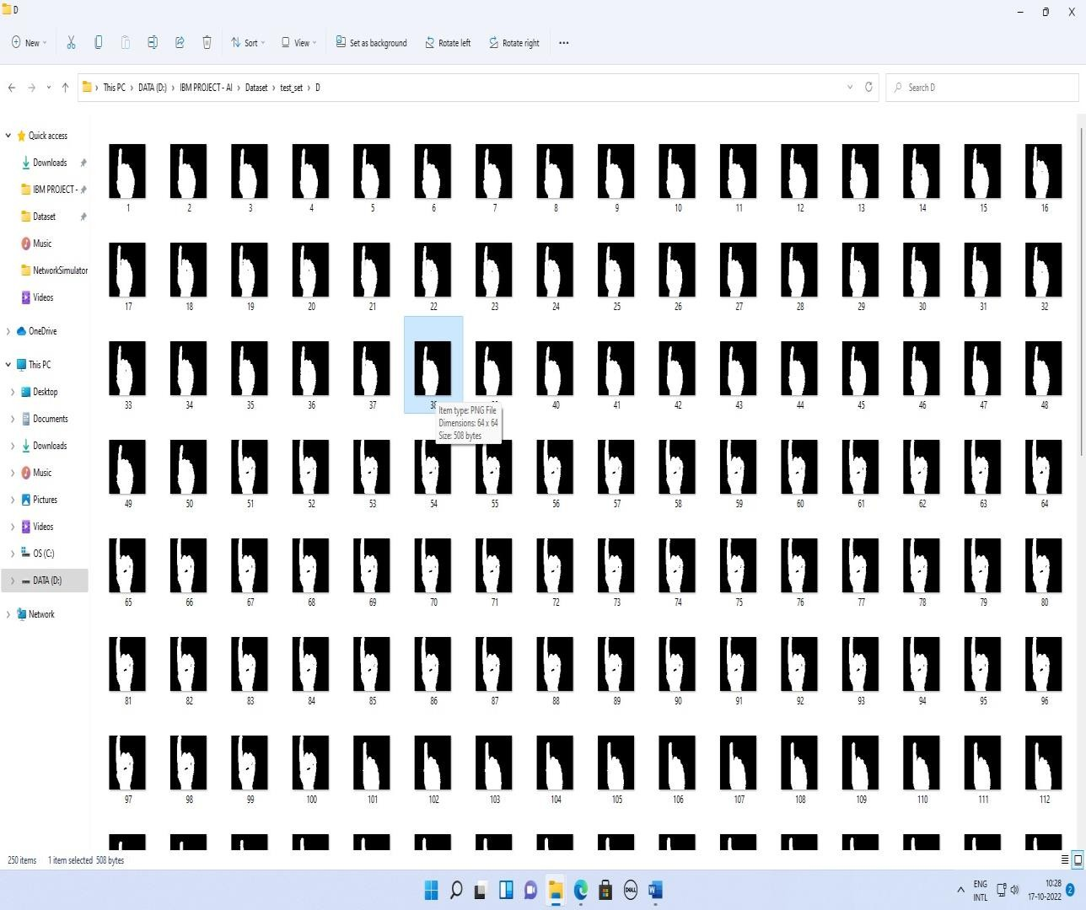

Stage 4: D:\IBM PROJECT – AI

